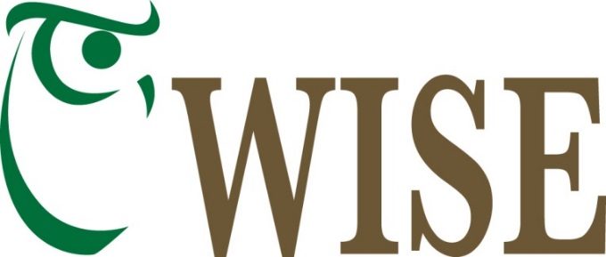
In-Class Science Program
2021-22 School Year
The WISE In-Class Science Program is available to all teachers in the Copper River School District and Valdez City Schools as well as home-school programs and families. We have science kits and experienced teachers available to come to your class and share hands-on lessons. Most of the lessons are designed to be approximately an hour long, but we are happy to work with classroom teachers to customize the content and length of presentations based on the needs of your class. Please see the reverse side of this flyer for this year’s class offerings.
This year the In-Class Science teachers will be:
- Robin Mayo, WISE Staff
- Jolene Nashlund, WISE Staff

To request a class, please call the WISE office at 822-3575, or email robin@wise-edu.org. Whenever possible, we will try to schedule several classes at a location to reduce travel costs.
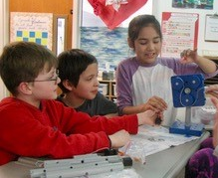
The In-Class Science program was established in 2011 with the help of grants from the Copper Valley Electric Association and Copper Valley Telecom, for the purpose of expanding opportunities for local students in the sciences. Lessons are designed to spark interest through hands-on exploration, and help fulfill grade level standards for science learning.
We appreciate the continued support of the Copper Valley Electric Association Community Foundation and Copper Valley Telecom who make this program possible.
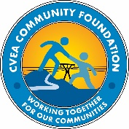
Wrangell Institute for Science and Environment
(907)822-3575, cell 259-3575 robin@wise-edu.org www.wise-edu.org

WISE In-Class Science Program 2021-22
All Classes are approximately one hour unless otherwise noted. We can customize length and content.
Magnetism Grades K-2: Understanding the unseen force of magnetism, distinguishing between magnetic and non-magnetic items, polarity, attract and repel, and everyday magnets. Hands on activities include manipulating lots of magnets, sorting magnetic and non-magnetic materials, and magnetizing steel.
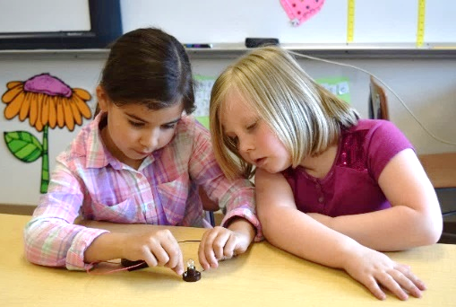
Introduction to Electricity Grades K-2: Covers the difference between static electricity and electric current, conductors and insulators, and creating simple electric circuits. Balloons are used for static electricity experiments, and batteries, wires and bulbs are assembled into circuits. Safety is an important element of this lesson.
Sound Grades 2-4: What makes sound, sound waves, frequency, intensity, and pitch? How the human ear works, and how to protect our hearing. This activity has a wide range of hands on materials including tuning forks, a megaphone/ear trumpet, pan lids to crash, and good old fashioned cup and string walkie-talkies.
Water Cycle Grades 4-6: This lesson begins with a review of the water cycle, and introduces the concept of a watershed. Then we use the interactive game “The Incredible Journey” in which students roll dice to simulate a journey through the water cycle, and map their results.
Skins and Skulls Grades K-6: WISE has a large collection of skins and skulls of local furbearers, from least weasel to grizzly bear, which we love to share with all ages. We have a lesson that divides them into families, explains the unique adaptations of each critter, and explores what can be learned about the diet and habitat.
Questions? Ready to schedule? Please call Robin Mayo at WISE 822-3575 or email robin@wise-edu.org

